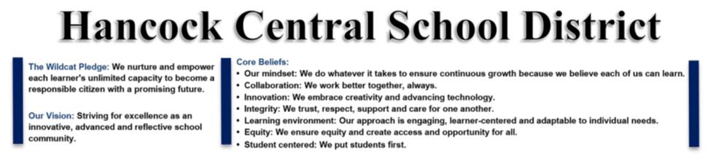
Award-winning author and illustrator visits Hancock Elementary School
HANCOCK – Illustrator and author Lee Harper visited Hancock Elementary School on Thursday, February 9, and spoke to students in grades pre-k through 6th about the inspirations for his work, and how they too could become illustrators or authors.
Harper is best known for his illustrations for Wendi Sivano in the best-selling Turkey Trouble Series, Walter Dean Myers in Looking for The Easy Life, and Leslie Helakoski in Woolbur and Ready or Not, along with Woolbur Goes To School. He has also written and illustrated books including Snow! Snow! Snow!, Coyote, and The Emperor's Cool Clothes.
When Harper was asked about his background and what he hopes students get from his presentations, he said, “In my presentations, I animate a talk with a PowerPoint about how my childhood love for animals, books, and art became the foundation of my grown-up career as an author and illustrator.”
“I also show how my farm and animals give me ideas for my illustrations and stories,” he added. “With the older children I go into more of the details of the actual process of making a book.”
The PowerPoint talk was followed by several interactive drawing activities, one of which involves the children trying to guess what we is being drawn based on the clues he gives them.
Those who are interested in learning more about what is going on in the Hancock Central School District may visit its Facebook page at facebook.com/HancockCSD or its website at hancock.stier.org for additional information.

