INSTALLING MICROSOFT OFFICE ON A
PERSONAL COMPUTER/LAPTOP AT HOME

There may be a need for you to work on Microsoft Office files on a non-school/work issued device. If you do not have access to Microsoft Office and need to access it, you can install it on a personal computer/laptop.

ACCESSING SCHOOL/WORK EMAIL FROM HOME BY USING AN INTERNET BROWSER
- Launch an Internet browser – most common Internet browsers are shown below.
Edge/Microsoft Edge
Chrome/Google Chrome

Internet Explorer
Firefox/Mozilla Firefox

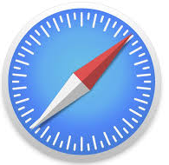
Safari (Mac, iPad, iPhone)

- In the address bar at the top of the screen, type in the following:
myapps.hancock.stier.org
and press/click Enter on your keyboard
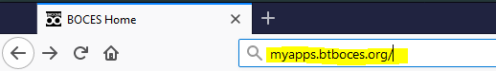

- You will land on the page shown below. In the Email Address box, type in your school/work email address. Your email address is typically the first letter of your first name followed by the first seven letters of your last name @hancock.stier.org – it is the same user name used to login the computer when at school/work.
Example: John Williams would use: jwilliam@hancock.stier.org
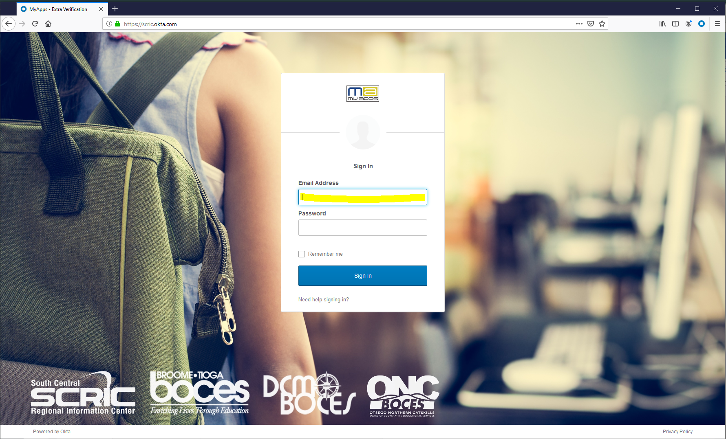

- In the password box, enter your password. It is the same password used to login to the computer when at school/work. If you do not know your password, please call 607-766-3800 and a service desk representative will assist you
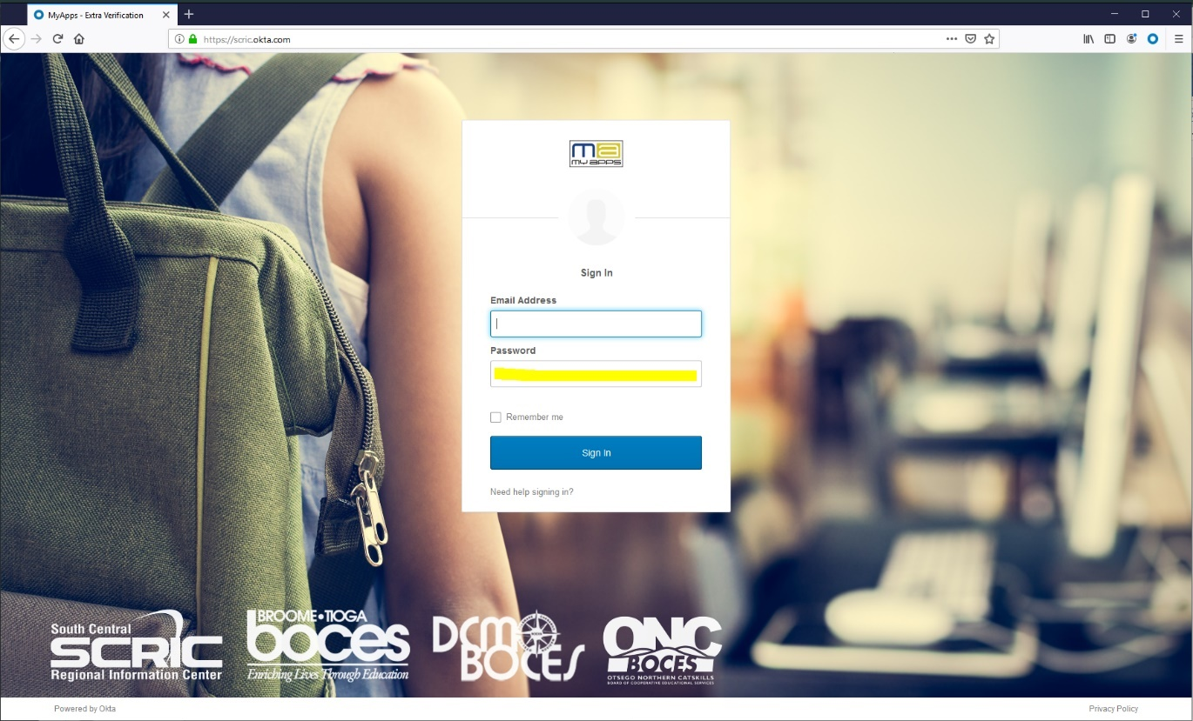

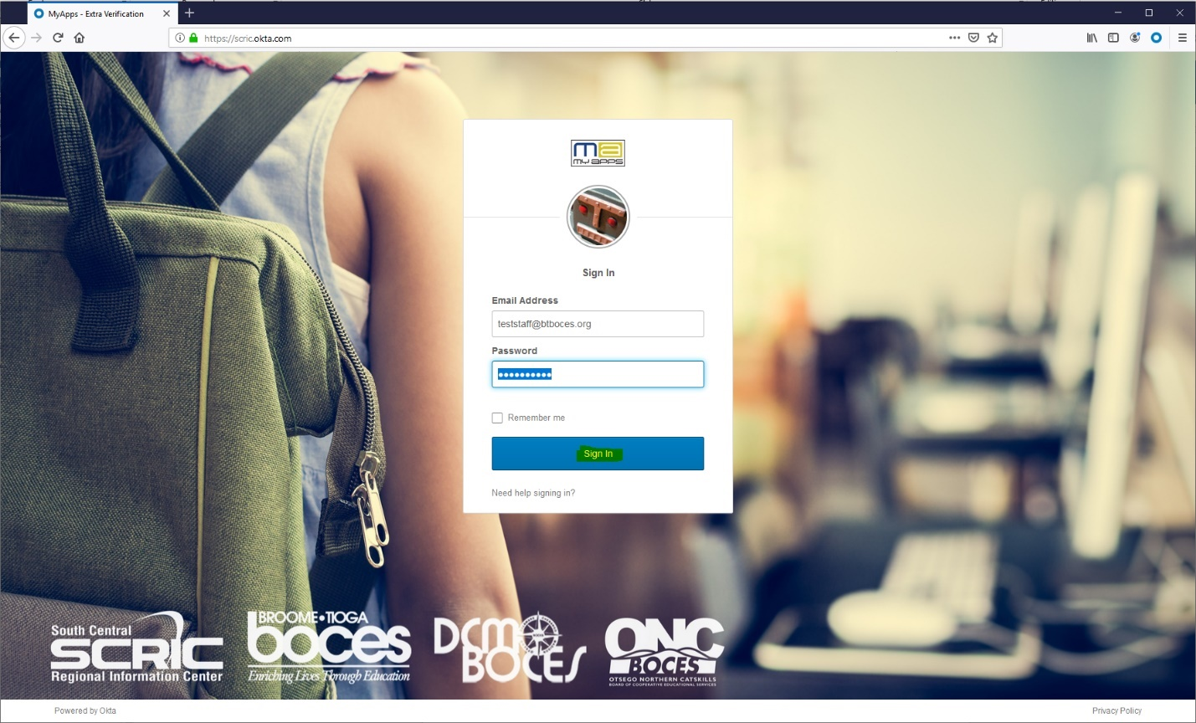
- Once you enter your email address and password, click the blue Sign In button
- If this is your first time signing in, you may see the screen below. If you do not see the screen below, please skip to step 8.

- The screen below allows you to set-up the ability to reset your password on your own in the future (known as password self-service reset). There are two options for setting up password self-service reset:
  - Option 1: using a secondary email address (ex: personal email address like Gmail, Yahoo, etc.)
  - Option 2: using a cell/mobile phone number
Note: You can skip this process by clicking the Create My Account button in the bottom right-hand corner of the screen.
This is optional: To use a secondary email address for password self-service reset, make sure the secondary email button is selected and enter your secondary email address. Note: you will receive an email from MyApps Notification to confirm your email address – click here for more information

If you use a secondary email address or cell/phone number, this is required. Next select an option from the dropdown Choose a forgot password question and enter an answer for the question

This is optional: To use a cell/mobile phone number, click the button Add Phone Number. A pop-up box will open for you to enter your cell/mobile phone number. Click on Send Code. Enter the code that is sent to your cell/mobile phone and click Verify. Once successful, click Done

If you use a secondary email address or cell/phone number, this is required. Click on an image (when you see this image, you know you are logging into our website).

Click the button Create My Account

- You will see an image similar to the one below. To download a copy of Microsoft Office to a non-school/work issued device, click on BTBOCES Office 365 Office Portal icon.

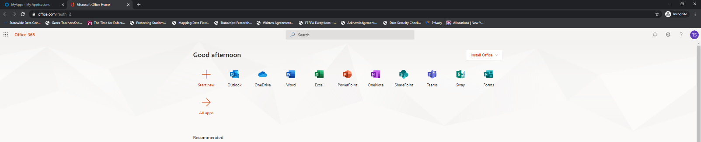
- An additional browser tab will open that is similar to the image shown below.

- Near the top of your screen to the right there will be an Install Office button with a dropdown as shown in the image below.
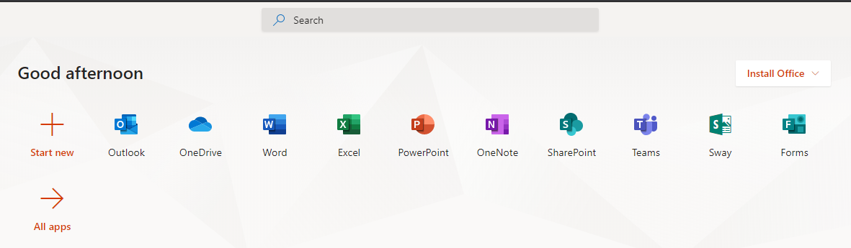

- When clicking the Install Office button dropdown, please select the first option Office 365 apps.

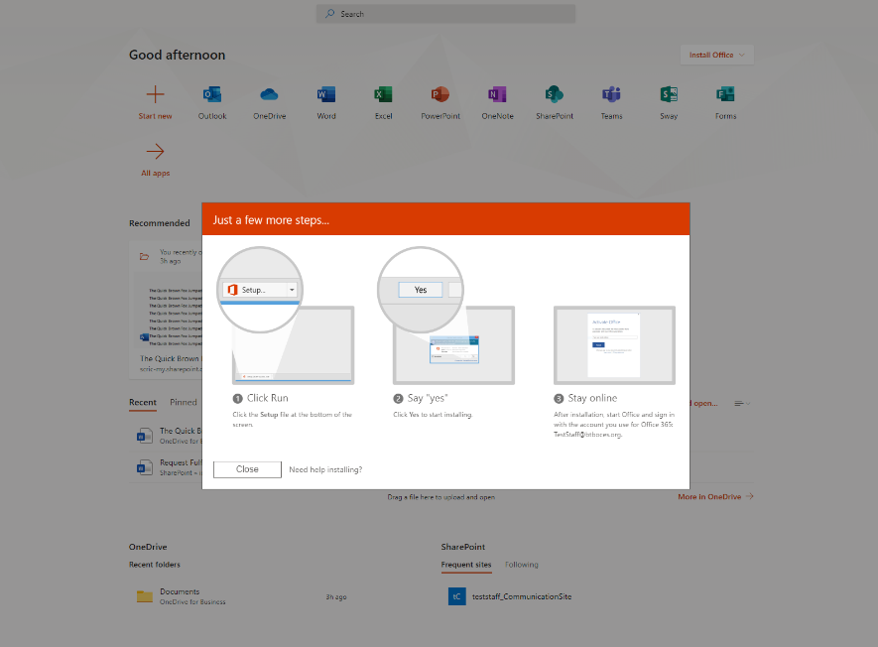
- Follow the steps provided on the screen to install the software as shown in the image below.

- Once complete, please make sure to return to your Internet browser window to the MyApps portal. In the upper right-hand corner, click the dropdown arrow by your user name and select Sign out. This ensures you are logged out.

