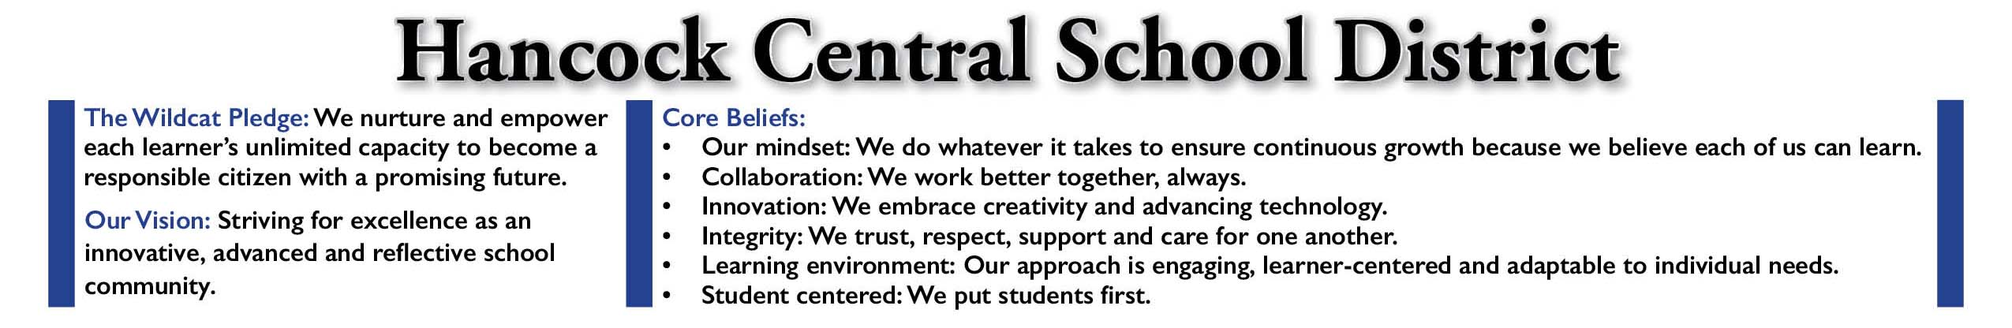

TO: HCS Faculty, Staff and Families
FR: Dr. Terrance Dougherty
RE: Boil Water Advisory
DATE: March 22, 2023

Good morning,

The Village of Hancock and the Delaware County Department of Health have issued a boil water advisory for the Hancock Middle/High School building. Drinking water stations and cups will be available in the MS/HS cafeteria for all faculty, staff and students.

We will update you as soon as the advisory has been lifted.

Thank you.

